SIMATS ENGINEERING
ASSESSMENT TOOL3-VIVA QUESTIONS

1. Open Services on a Windows System
Question
How would you evaluate the security posture of a Windows system after identifying multiple open services?
Answer
I would first identify the open ports and running services using a network scanner. Then I would determine the service versions and check whether they have known vulnerabilities. Unnecessary or outdated services should be disabled or patched. The risk is higher when sensitive services are exposed to untrusted networks.
Implementation
Run in Kali:
nmap -sV 127.0.0.1
Expected output
You may see something like:
PORT STATE SERVICE VERSION
22/tcp open ssh OpenSSH
80/tcp open http Apache
+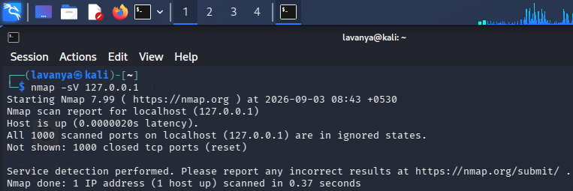

2. Exposed RPC Service
Question
How would you evaluate the security risk associated with an exposed RPC service?
Answer
I would identify RPC-related ports and determine which services are running on them. I would check whether the service is necessary, properly configured and patched. An exposed RPC service may allow unauthorized users to interact with system functions, increasing the risk of information disclosure or unauthorized access.
Implementation
nmap -sV -p 135,139,445 127.0.0.1
Expected output
PORT STATE SERVICE
135/tcp open msrpc
139/tcp closed netbios-ssn
445/tcp closed microsoft-ds
Your output may be different depending on your system.
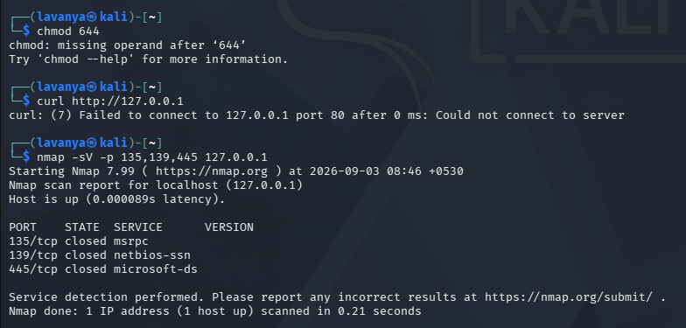

3. Unnecessary Services in Linux
Question
How would you evaluate the security risks of unconnected or unnecessary services running on a Linux system?
Answer
I would list the active services and identify services that are not required. Unnecessary services increase the attack surface because each running service may contain vulnerabilities or configuration weaknesses. Unused services should be disabled and regularly monitored.
Implementation
First run:
systemctl --type=service --state=running
Then:
ss -tuln
Expected output
LISTEN 0 128 0.0.0.0:22
LISTEN 0 128 127.0.0.1:631
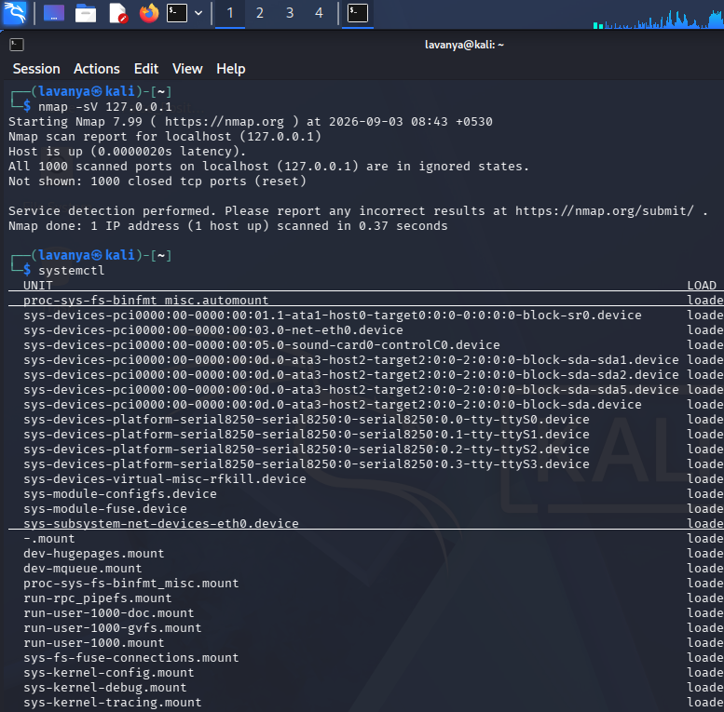
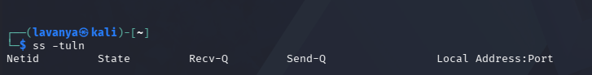
Conclusion
The results show which services are actively running and which network ports are listening. Services that are not required should be disabled to reduce the attack surface.

4. Incorrect Linux File Permissions
Question
A Linux file has incorrect permissions that allow unauthorized modification. How would you evaluate the resulting security risk?
Answer
I would inspect the file ownership and permissions using ls -l. If unauthorized users have write permission, they may modify the file and potentially affect system operations or application behavior. I would correct the permissions and verify them again.
Implementation
Create a test file:
echo "Security Test" > testfile.txt
Check permissions:
ls -l testfile.txt
Give everyone write permission for demonstration:
chmod 666 testfile.txt
Check again:
ls -l testfile.txt
Expected output
Initially:
-rw-r--r-- 1 user user ... testfile.txt
After chmod 666:
-rw-rw-rw- 1 user user ... testfile.txt
The rw permissions for others show that other users can modify the file.
Then fix it:
chmod 644 testfile.txt
Verify:
ls -l testfile.txt
Conclusion
Weak file permissions can allow unauthorized modification. Restricting write access reduces the possibility of tampering.
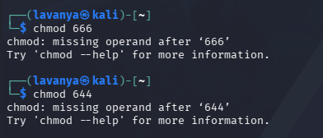

5. SQL Injection in a Web Application
Question
A web application is vulnerable to SQL injection. How would you evaluate the severity of this vulnerability and its possible consequences?
Answer
I would determine whether user input is directly included in SQL queries without proper validation or parameterization. I would assess whether the vulnerability could expose, modify or delete database information. Severity depends on the sensitivity of the data, authentication requirements and the level of access obtainable. Parameterized queries and input validation should be used to prevent SQL injection.
Safe local implementation
If you already have a local web application for testing, check its login/input fields using a controlled test environment.
For example, first verify that your local web server is running:
curl http://127.0.0.1
Expected output
You should receive HTML content such as:
HTML
<html>
...
</html>
If you are using DVWA/OWASP Juice Shop, you can perform the SQL-injection experiment inside that intentionally vulnerable lab instead of testing a real website.
